**Вложени условни конструкции**

1. **Switch-case**

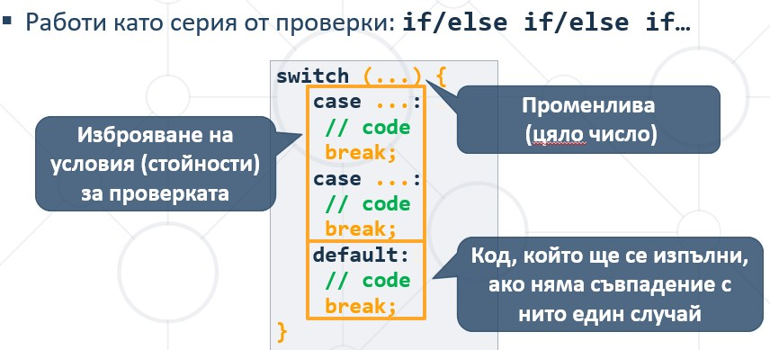

1. **Вложени условни конструкции**

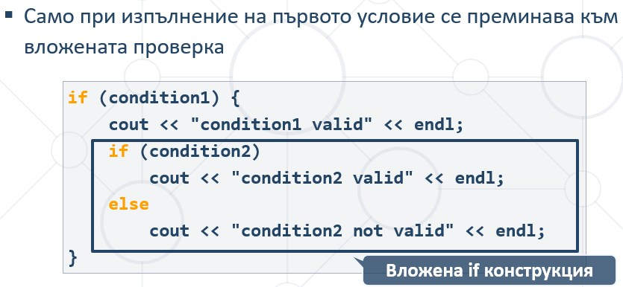

1. **Логически оператори**

